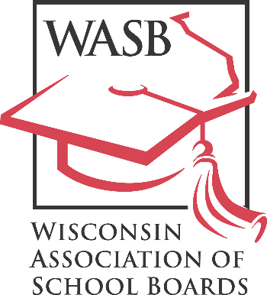
John H. Ashley, Executive Director
“Leadership in Public School Governance”

122 W. Washington Avenue, Madison, WI 53703
Phone: 608-257-2622 Fax: 608-257-8386
FOR IMMEDIATE RELEASE
[DATE]
Contact: Sheri Krause, WASB communications director
Phone: 608-512-1705

[SCHOOL DISTRICT] School Board Member Honored for Commitment to Professional Development

[SCHOOL DISTRICT NAME] school board member [BOARD MEMBER’S NAME] has been recognized by the Wisconsin Association of School Boards (WASB) for their commitment to professional development.

[BOARD MEMBER’S LAST NAME] has earned Level [NUMBER] recognition by attending training opportunities focused on student achievement and improving public education by the Wisconsin Association of School Boards and/or the National School Boards Association.

The WASB’s Member Recognition Program tracks the professional development of board members, who may be awarded one of five achievement levels based on a point system. Members receive points by attending the State Education Convention, participating in workshops and a variety of other professional development activities. To learn more, please visit our website.

As it stems from a board member’s journey to deepen their understanding of school governance and leadership, member recognition reflects the member’s commitment to their community.

WASB Executive Director John Ashley recognizes [BOARD MEMBER’S LAST NAME]’s accomplishments.

“Board members begin their service with a desire to help children in their community reach their potential,” he said. “[BOARD MEMBER’S LAST NAME] is taking concrete steps to build on that foundation by developing their leadership and governance skills.”

The Wisconsin Association of School Boards is a nonprofit association that provides information and services to Wisconsin school boards in the areas of school law and policymaking, bargaining, legislation and leadership development.

